Dimension

Definition
# Source: AI Source: Provided by: [Data Path: Persons Table -> ID Column: 1, Name_En Column: Motasem Essam] -> From: [ChatGPT] on [7/20/2026]
A Dimension is a measurable extent or direction in which an object exists. It describes how an object occupies space and determines the minimum number of independent measurements needed to specify its size or position.
In geometry, dimensions are used to classify geometric objects based on the number of directions in which they extend.

Purpose
# Source: AI Source: Provided by: [Data Path: Persons Table -> ID Column: 1, Name_En Column: Motasem Essam] -> From: [ChatGPT] on [7/20/2026]
Dimensions are used to:
- Classify geometric objects.
- Describe the size and shape of objects.
- Define geometric spaces.
- Support mathematical modeling.
- Enable accurate measurement and visualization.
- Distinguish between points, lines, planes, and solids.

Types of Dimensions

1. Zero-Dimensional (0D)
# Source: AI Source: Provided by: [Data Path: Persons Table -> ID Column: 1, Name_En Column: Motasem Essam] -> From: [ChatGPT] on [7/20/2026]
A zero-dimensional object has no measurable extent in any direction.
Characteristics
- No length
- No width
- No height
- Represents only a location
Example
- Point

2. One-Dimensional (1D)
# Source: AI Source: Provided by: [Data Path: Persons Table -> ID Column: 1, Name_En Column: Motasem Essam] -> From: [ChatGPT] on [7/20/2026]
A one-dimensional object extends in one direction.
Characteristics
- Has length
- No width
- No height
Examples
- Line
- Line Segment
- Ray

3. Two-Dimensional (2D)
# Source: AI Source: Provided by: [Data Path: Persons Table -> ID Column: 1, Name_En Column: Motasem Essam] -> From: [ChatGPT] on [7/20/2026]
A two-dimensional object extends in two independent directions.
Characteristics
- Has length
- Has width
- No thickness
Examples
- Square
- Rectangle
- Triangle
- Circle
- Polygon
- Plane

4. Three-Dimensional (3D)
# Source: AI Source: Provided by: [Data Path: Persons Table -> ID Column: 1, Name_En Column: Motasem Essam] -> From: [ChatGPT] on [7/20/2026]
A three-dimensional object extends in three independent directions.
Characteristics
- Has length
- Has width
- Has height (depth)
Examples
- Cube
- Sphere
- Cylinder
- Cone
- Prism
- Pyramid

5. Higher Dimensions (4D and Beyond)
# Source: AI Source: Provided by: [Data Path: Persons Table -> ID Column: 1, Name_En Column: Motasem Essam] -> From: [ChatGPT] on [7/20/2026]
Mathematics also studies spaces with four or more dimensions.
Examples include:
- Four-dimensional space
- n-dimensional geometry
- Vector spaces
- Hyperspace
These are primarily used in:
- Advanced mathematics
- Physics
- Computer science
- Machine learning
- Data analysis

Dimensional Classification
# Source: AI Source: Provided by: [Data Path: Persons Table -> ID Column: 1, Name_En Column: Motasem Essam] -> From: [ChatGPT] on [7/20/2026]
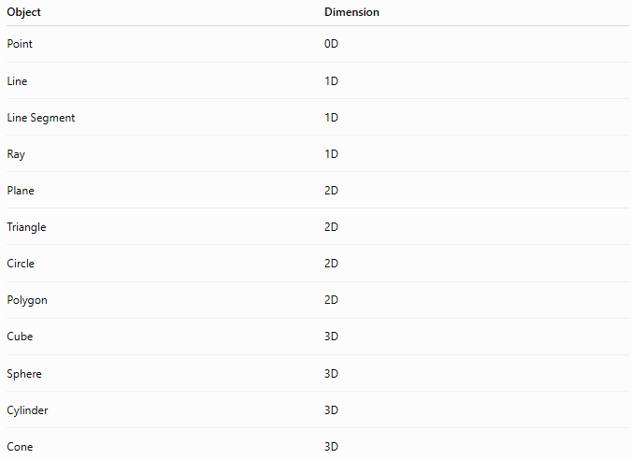
Object | Dimension
Point | 0D
Line | 1D
Line Segment | 1D
Ray | 1D
Plane | 2D
Triangle | 2D
Circle | 2D
Polygon | 2D
Cube | 3D
Sphere | 3D
Cylinder | 3D
Cone | 3D

Measurements by Dimension
# Source: AI Source: Provided by: [Data Path: Persons Table -> ID Column: 1, Name_En Column: Motasem Essam] -> From: [ChatGPT] on [7/20/2026]
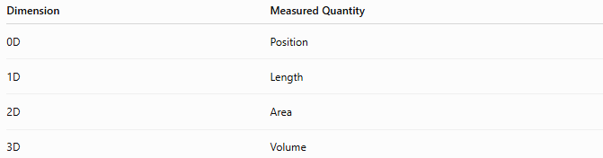
Dimension | Measured Quantity
0D | Position
1D | Length
2D | Area
3D | Volume

Applications
# Source: AI Source: Provided by: [Data Path: Persons Table -> ID Column: 1, Name_En Column: Motasem Essam] -> From: [ChatGPT] on [7/20/2026]
Dimensions are used in:
- Geometry
- Engineering
- Architecture
- Physics
- Computer Graphics
- CAD
- Manufacturing
- Robotics
- Surveying
- GIS
- Mathematics

Advantages
# Source: AI Source: Provided by: [Data Path: Persons Table -> ID Column: 1, Name_En Column: Motasem Essam] -> From: [ChatGPT] on [7/20/2026]
Understanding dimensions helps to:
- Classify geometric objects.
- Select appropriate measurement methods.
- Model physical systems.
- Visualize mathematical concepts.
- Support engineering and scientific design.

Limitations
# Source: AI Source: Provided by: [Data Path: Persons Table -> ID Column: 1, Name_En Column: Motasem Essam] -> From: [ChatGPT] on [7/20/2026]
Dimensions:
- Are mathematical abstractions.
- Higher-dimensional spaces cannot be directly visualized.
- Physical objects may not perfectly match ideal geometric models.

Comparison
# Source: AI Source: Provided by: [Data Path: Persons Table -> ID Column: 1, Name_En Column: Motasem Essam] -> From: [ChatGPT] on [7/20/2026]
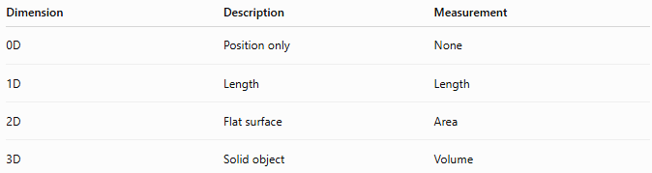
Dimension | Description | Measurement
0D | Position only | None
1D | Length | Length
2D | Flat surface | Area
3D | Solid object | Volume

Key Points
# Source: AI Source: Provided by: [Data Path: Persons Table -> ID Column: 1, Name_En Column: Motasem Essam] -> From: [ChatGPT] on [7/20/2026]
- A Dimension describes the measurable extent of an object.
- Geometry commonly studies:
  - 0D → Point
  - 1D → Line
  - 2D → Plane figures
  - 3D → Solids
- Each additional dimension introduces a new independent direction.
- Different dimensions require different types of measurements, such as length, area, and volume.

Conclusion
# Source: AI Source: Provided by: [Data Path: Persons Table -> ID Column: 1, Name_En Column: Motasem Essam] -> From: [ChatGPT] on [7/20/2026]
A Dimension is a fundamental concept in geometry that describes how an object extends through space. It provides the basis for classifying geometric objects into zero-, one-, two-, and three-dimensional forms and determines the appropriate methods for measuring them. Understanding dimensions is essential in mathematics, engineering, architecture, physics, computer graphics, manufacturing, and scientific modeling, forming the foundation for both classical geometry and advanced spatial analysis.

